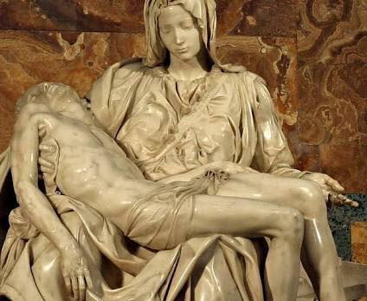

Maria Desolata

From: Igino Giordani, Maria modello perfetto, (Rome: Città Nuova, 2001), pp 118-127, Our translation (Romeo Vital - Philippines)

In the following text Igino Giordani reflects on Mary as the “collaborator” of the Redeemer who, through her desolation, became Mother of the human family.

“While Christ and His teaching broke into history, tearing it in two, pushing humanity towards repentance and change and putting the new self into action in a new city, that tear was also at work in the heart of Mary who stood between those two ages and two mentalities, which sometimes made it a bitter effort to understand, follow and be one with Jesus.

The lesson and the suffering didn’t end there. It reached to the point during her Son’s preaching that she wasn’t able to draw near to Him, to be admitted into His presence. Mary was becoming what Simeon’s prophecy had foretold, the Mother Desolate.

The term “desolate” is meant to intensify for us the solitude in which she suffered when Jesus went away to begin His public ministry, leaving her in Nazareth, a widow amongst hostile relatives; and when he later left her as His Mother, substituting Himself with the beloved disciple as her child. She was alone among all, blessed among women, mother of the human family: the New Eve.

Through her suffering the sorrowful Mary participated in generating the Church; that is, the People of God that was entrusted to her in the person of John, by Christ Himself. John, the beloved disciple, was given to her as a son, the son in place of Jesus, or better, an other Jesus.

And so, the prophecy of Simeon that had initiated the martyrdom of the Virgin reached its culmination on Calvary as an iron lance pierced the breast of Jesus and that same lance pierced Mary’s soul.

Beneath the cross, Mary is clearly the woman of the people who stands with God. One can truthfully say that Jesus was somehow in need of her not only to be born, but also to die. Then came that moment on the cross when He felt abandoned by the people of the earth and by His Father in Heaven. He turned to His Mother who was standing at the foot of the cross, to that Mother who had not deserted Him, overcoming Her human nature so as not to cave in beneath such a trial.

And when the Son was dead, the Mother continued to suffer. He was placed on her lap, more powerless now than when He was but a child. A dead God resting on the lap of a widowed mother! Now she was truly the Queen because Jesus had recapitulated humanity, past present and future, and now it could rest as it lay guarded on Mary’s lap. In that sorrowful desolation Mary is presented as the Mother and Queen of the human family as it walks its own paths of sorrow. Her greatness was equal to her anguish, the suffering of a Mother who found herself watching over humanity as it swooned beneath its exile and guilt.

When the Mother of Fair Love became also the Mother of Sorrows, and the seven gifts of the Spirit turned into seven swords, the wound that was opened in her heart, along with the wound of the Son, would convey the whole of humanity to the Father and return humanity to its source. Thus she was the collaborator of the Redeemer, but it was also precisely that work which made her more truly the Mother of Fair Love. There she united with us, there she identified herself with our fate. In this way humanity was reborn, and in this way the Church was born.”

